**Autumn Volunteer Newsletter**

**Valerie’s introduction**

Dear Volunteers,

As 2023 draws to a close we wish to focus on the true impact that your volunteering has, and how important you are to TaxAid and Tax Help for Older People.

We start the newsletter remembering those we have lost; the incredible Rosina Pullman, ex-CEO of TaxAid, and John Sargent, long-standing Volunteer of Tax Help for Older People. We wish to take a moment to remember everyone who has given their time to the tax charities who has passed away within the last year, we are truly lucky for their dedication and support, they will be missed.

We also talk about the incredible impact your volunteering has had, not least that in 2022/23 TaxAid volunteers helped to cancel £753,811 of tax debt for our beneficiaries’ and volunteers for Tax Help for Older People helped generate tax refunds of £389,013. It is inspiring to see these totals, and the full breadth of the charities' impact. We will share more data from 2022/23 later in the newsletter.

Deborah, our Director of Fundraising, updates us on fundraising news, celebrating our fundraising wins. Topping off the year with our Christmas fundraising campaign, asking those who can spare, to please donate the last hour of your pay to the tax charities this Christmas.

We also take a look at staff changes, and some technical updates. Sam, our Volunteer Manager, also updates us on some of the results from the volunteer information update, so many thanks again to all of you for filling this out.

I’m also sending out a plea to the wordsmiths amongst you, as we are looking for talented writers and proof readers from the tax profession to help us with a special project. If you think this could interest you please email [kerry@taxaid.org.uk](mailto:kerry@taxaid.org.uk) to find out the details.

Many thanks for your continued dedication to the tax charities. The impact we have on the lives of the most vulnerable in our society is dependent on your support. The staff on our helplines respond every day to requests for help, but the only way we have confidence that we are able to give our callers the additional help they need is by getting in touch with you. While you may feel like you support only a few people a year, together you are part of a team of 30 staff and over 400 volunteers, who in 2022/23 supported 13,965 vulnerable people who contacted us for help.

Finally, I want to wish you all Happy Holidays and best wishes for 2024.

Valerie Boggs,

CEO of TaxAid and Tax Help for Older People

**In Memory**

Rosina Pullman had a big impact on TaxAid, developing it into the charity that it is today. Stephen Banyard, trustee at TaxAid, wrote this wonderful tribute to her memory for Taxation magazine: <https://www.taxation.co.uk/articles/appreciation-of-life-rosina-pullman>

The article from this link is pasted below:

[It is with great sadness that we report the death of Rosina Pullman on 12 September after a short illness. She was 74.

Rosina did a remarkable job as director of TaxAid, serving from 2001 to 2016. She was a highly effective fund raiser who put an excellent young charity onto a firm financial footing – while at the same time transforming and growing it substantially, making it a significant player in the tax world. Her work was recognised in 2016 when she received the lifetime achievement award at the Taxation Awards.

Coming from a non-tax background, some were initially sceptical about her running a tax charity. Rosina had read international studies at LSE and worked at Chatham House before becoming a fund raiser, first at Oxford, then with Friends of the Elderly, finally at the Bethlem Hospital. But at TaxAid, an early achievement was her quickly winning support by demonstrating the wide extra value she brought.

Rosina did not pretend to be a tax expert but she built a strong understanding of our vulnerable beneficiaries – which gave TaxAid a unique offering. She cared strongly how vulnerable people were treated and insisted that everyone who came to TaxAid for help was treated with understanding and respect – it was not enough to get the tax right. Empathy for the beneficiary became part of the TaxAid way of doing things. She saw that TaxAid’s beneficiaries had ‘messy lives’ and that understanding these was central to solving their tax problem. She was interested in their lives and deeply moved by the harrowing circumstances many of them suffered. This experience was freely shared and for example enabled TaxAid to work with HMRC when it designed its ‘extra support’ service.

The charity grew substantially under her leadership, both in terms of the numbers helped and its reach. Working with the big four, volunteers in their offices were recruited to provide a face-to-face service, first in Birmingham, then Manchester and Newcastle. One staff member worked with CAB offices so that TaxAid could support them across the country with tax problems they received. Individual volunteers were also an essential element of delivering the service – Rosina grew this group significantly, several later joining the staff, including Valerie Boggs, TaxAid’s current CEO.

Innovation was another key element of Rosina’s success. Early on, a virtual call centre was established enabling home working – an important offering then in the employment market. A digital data base introduced in 2008 proved hugely valuable – and a source of envy for a visiting HMRC team shortly after.

These developments were made possible because of her skills in attracting support, both funding and pro bono help. Early on, she was bold in approaching the heads of large tax firms to support the charity. She won funds from foundations including the Lottery. Gradually, this and growing support from HMRC put TaxAid on a much stronger financial footing.

Most importantly, she built on the mutually beneficial long-term relationship with HMRC. This included TaxAid providing support during the roll out of tax credits; later, when HMRC had problems with PAYE reconciliation; and when the enquiry centres were closed. It enabled TaxAid, in partnership with MIND and CAB, to persuade HMRC to reform its debt management processes in 2012 to take into account the debtor’s mental health. HMRC in turn, made TaxAid’s work more effective by introducing a FastTrack service and generally supporting TaxAid because it could better reach some vulnerable people and because of its understanding of them.

Rosina’s empathy for TaxAid’s beneficiaries was matched by her care for her staff. She nurtured and developed them while letting them get on with the job. She played to peoples strengths and circumstances and designed jobs around these – building a talented and committed team. She was good to work for, had a remarkably positive approach to life and was great fun to be with.

Rosina remained ‘remorselessly cheerful’ to the end and is greatly missed by her family and friends. She leaves her husband Gerald Pollio, daughter Laura, son Dominic and grandson Reggie. – Stephen Banyard.]

John Sargent, born 1930, a long standing and valued Tax Help for Older People volunteer, sadly passed away in July. Samantha, our Volunteer Manager, spoke to his daughter to hear about his incredible life and wrote this piece in his memory: <https://taxaid.org.uk/a-tribute-to-john-sargent>

The article from this link is pasted below:

[John Sargent, born in 1930, a long-standing and valued Tax Help for Older People volunteer, sadly passed away in July. Married to Joy for 65 years, John had 3 children, Penny, Katie and Richard.

John, at 93 years, continued to support us and our beneficiaries, until May this year, despite failing physical health. Described by his daughter, Penny, as quiet and humble, tenacious, and a “champion of the individual and of small businesses”.

Born at St Thomas’ Hospital, John was raised initially in North London and then in Purley. At the age of 11, John won a scholarship to Caterham School, Surrey, where he thrived.

John devoted his life to helping other people, both as an accountant and through his volunteering work. For 35 years he volunteered for SSAFA, the Armed Forces charity. He also volunteered for the Scout Association, the Welsh Hockey Association and his local church. John ran our Tax Help surgery at Cwmbran.

John died from chronic heart failure on 22 July 2023; Penny tells us “Even up until the last week of his life he was concerning himself with helping others – advising the nursing staff about claiming (backdated) uniform allowance, telling one of his visitors how to sort the probate for her late father and advising another friend to apply for council tax relief and attendance allowance on account of her husband’s recent diagnosis.

… and though clearly I am biased, I have no hesitation in saying my father was a wonderful man, who invariably put others before himself and whose integrity, kindness and generosity made this world a better place for very many people.”

John was a dedicated advocate of our charities’ work, and he will be missed by us all.]

**You make a difference**

In 2022/23 our work had an incredible impact on the people that need our help. They gave us feedback such as ‘I cannot begin to describe the sense of relief I feel and I thank you so much for what you have done for me.’

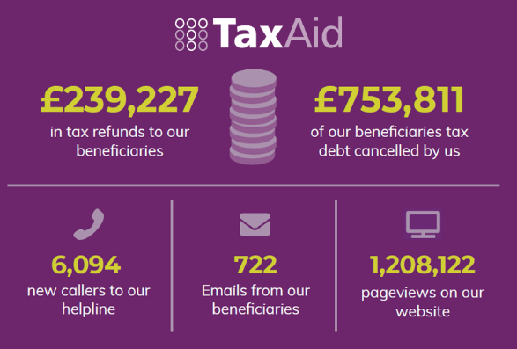

At TaxAid we helped people like Sophie, whose severe depression and health issues led to tax debts piling up, and how our support helped to free her of the burden of tax debt. Read this story here: <https://taxaid.org.uk/sophies-tax-nightmare-10000-in-tax-debt>

The article from this link is pasted below:

[Sophie’s Tax Nightmare: £10,000 in tax debt

She was suffering from severe depression and numerous other health conditions. This stemmed from a series of related misfortunes: an eviction, the loss of her business, the loss of all her records and bank statements, and a broken relationship.

The huge debt she had accumulated felt too much to cope with. The numerous demanding statements from HMRC led to her burying her head in the sand, ignoring all correspondence. Her health deteriorated and she felt trapped, with nowhere to turn.

After Sophie called TaxAid’s helpline, one of our volunteers, Cathy, took on her case. Over the course of several interactions she pieced together Sophie’s business accounts and then began negotiating with HMRC on Sophie’s behalf.

As a result, the penalties for Sophie’s business accounts for in-date years came down to zero. Additionally, an application for Special Relief for the out-of-date years was accepted. In the end, HMRC actually owed Sophie £138.

With TaxAid’s help and support, Sophie is now free of tax debt. The stress and worry that had hung over her for years has also gone and she has been able to move forward with her life.

This is Sophie’s story, without our support she wouldn’t have known how to piece together her business accounts or reduce her tax debt. Our mission is to ensure no one like Sophie pays a tax debt that they do not owe or understand.]

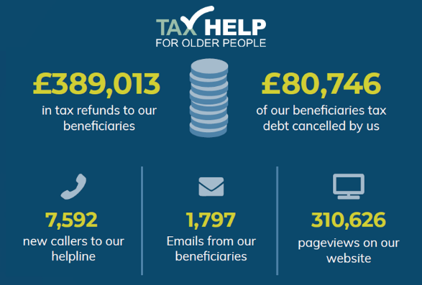

In 2022/23 Tax Help for Older People supported people like Joan, whose tax problems came around following the loss of her partner. Read this story here: <https://taxaid.org.uk/joans-story-the-fiscal-challenges-of-grief>

The article from this link is pasted below:

[Joan’s story: The fiscal challenges of grief

We often hear from widowers, like Joan, who are struggling financially following the loss of their life partner. Who, amidst this struggle, are then hit by a surprise tax bill or outstanding tax debt that they do not understand.

Joan was recently widowed. Without her husband’s pension, she was struggling, trying to manage on a lower income than she was used to.

When she received a high bill from HMRC, with no savings and on her low income, she had no idea how she would ever be able to pay this. She also had no idea why she had received the bill in the first place.

When she called our helpline, she was clearly agitated and distressed. The financial burden of losing her partner had already been quite significant. Our helpline adviser explained that due to the death of her husband, and a change in pension entitlement, a tax liability had risen, and unfortunately, the tax bill was correct.

However, our adviser reached out to HMRC detailing Joan’s financial circumstances, resulting in the cancellation of her tax debt. This lifted a weight off Joan’s shoulders.

Due to our charity, Tax Help for Older People, supporting older people, it is not unusual for us to hear from widowers. The financial fallout of losing a life partner can be significant and can lead to tax problems. It can be especially difficult for our beneficiaries when these issues arise at a time when their emotional upheaval from the loss is still quite raw.

It is with thanks to our dedicated volunteers for their empathy, understanding and expert tax knowledge, that we can help people like Joan through these difficult circumstances.]

**Tax Help for Older People Volunteers: Are you free?**

As we prepare for the holiday festivities, we understand that your availability to volunteer may be changing due to your work or other commitments. We know this is only temporary, and we very much appreciate all the support you give, but as the deadline for submitting online Tax Returns approaches, it would be helpful for us to know who has time to help, to ensure we are only reaching out to volunteers who have capacity, during this busy period.

If you are a Tax Help for Older People volunteer, please could you get in touch and update us on your capacity to take on new cases over the next couple of months. You can email Samantha, Volunteer Manager: [taxvol@taxvol.org.uk](mailto:taxvol@taxvol.org.uk). Thank you for all your help.

**Fundraising news**

Firstly, I would like to thank all our volunteers who have fundraised or donated to the charities this year. Thank you for your commitment and fantastic support.

We are currently awaiting the results of our bids to HMRC’s recent funding round. We believe we have made strong applications for both TaxAid and Tax Help for Older People, not least because of the specialist tax advice and support that our volunteers provide—so thank you.

In other news, The London Legal walk took place on 13th June when we were blessed with one of this summer’s few hot and sunny days. An incredible 112 supporters walked in aid of the charities and raised £12,474.75 for the charities, a fantastic achievement. This was a fitting final hurrah from Rose Over who retired from the charities in October. Rose provided huge support for fundraising, including coordinating the London Legal Walk, and will be greatly missed.

Also, in June, Alison Delorie organised a guided walk around Sir Christopher Wren’s churches in this the tercentenary year of his death. The walk raised a fantastic £1,144. Building on the success of this event, Alison is organising a walk on the theme of Shakespeare, confirmed for 21 May 2024. If you would like to take part, please email Alison at: [alison.lovejoy.delorie@btinternet.com](mailto:alison.lovejoy.delorie@btinternet.com)

If you would like to fundraise for the charities we’d love to hear about your plans. Please do get in touch by emailing [fundraising@taxvol.org.uk](mailto:fundraising@taxvol.org.uk).

Finally, this year, the charities are launching a joint Christmas fundraising campaign, a **Last hour’s Pay campaign.** It would be fantastic if you could share the flyer below with colleagues and friends in the tax profession (and beyond). As volunteers, you know that we have seen increasing numbers of vulnerable people turning to us for support this year and also the huge difference that the work you do makes to the individuals you help. So please support our Last Hour’s Pay campaign in any way you can, thank you.

Deborah Graham-Vernon

Director of Fundraising

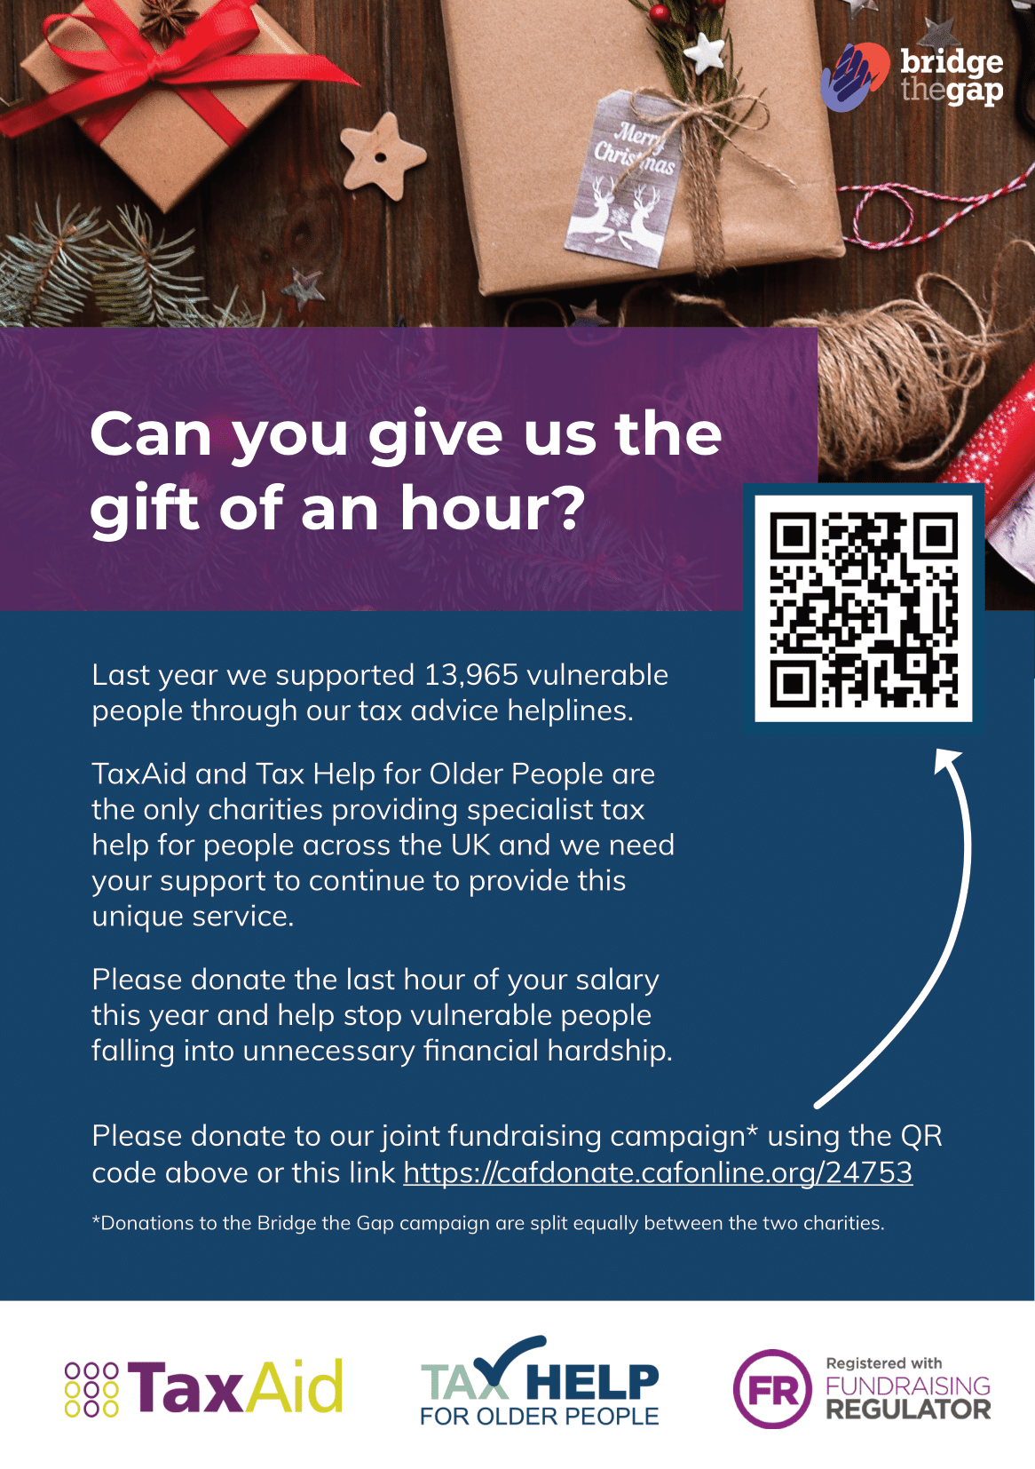

**Staff Changes: Hello and Goodbye**

Brian Chapman has joined the charities as Director of Finance and Infrastructure, below he introduces himself:

“I was very pleased to join the charities in July as Director of Finance & Infrastructure. Having spent over 30 years working in tax, I well understand the challenges of the tax system and dealing with HMRC.  As a result, I supported the tax charities for many years and became a trustee of Tax Help in 2021.  Last year I climbed Kilimanjaro as part of a small team to raise money for the charities. I now hope to be able to make a difference on a more day-to-day (and less physically challenging!) basis.”

We said Goodbye to Rose Over and Shila Wheeler in the last few months and were sad to see them go. Valerie Boggs shared this fitting tribute to Rose Over:

“There is no accolade that would be sufficient to reflect Rose’s contribution to the work of Tax Help and TaxAid. The amazing ability that Rose had to support staff, volunteers and donors was exemplary, impossible to replicate, but necessary to emulate.

In essence, Rose made things happen; from the London Legal Walk, to staff lunches. From mailchimp circulation to hundreds, to each email enquirer, Rose treated everyone with the same level of respect and was always courteous and discreet. She was fastidious and focused in every task, and endlessly ready to tackle a new challenge. I wish her every happiness in her plans for retirement.”

Paulette Ward has written this tribute to Shila:

After 13 years with Tax Help, Shila Wheeler left us in September to pursue a new career. Shila joined the Admin Team, later to become the Booking Team, in April 2010. For many new Volunteers Shila was their first point of contact with Tax Help as she booked beneficiary appointments, issued CARs and answered volunteer queries. Shila was solely responsible for overseeing the annual HMRC audit of Recorded Consent records - which we always passed - and for ensuring that the Fast Track forms we received were completed to HMRC standards. In Shila’s farewell email to staff she said “the Volunteers are so amazing helping our clients … I have had so many lovely messages from them over the past month, so many have become friends even though we never met them.”

**Technical update: Working with HMRC’S VSTRS Team**

As many of you will know, HMRC’s Voluntary Sector Resolution Service (known as ‘VSTRS’) – you may know it better as Fast Track - is critical to the service we provide. VSTRS offer us a fast and effective way of resolving taxpayer issues without long holding times and with consistency of service.

VSTRS was established to support participating voluntary sector organisations, such as Tax Aid and Tax Help for Older People, to deal with their more vulnerable taxpayers. The service aims to make it easier for HMRC, the voluntary sector and beneficiaries to resolve tax issues whilst also managing the risks to HMRC of unauthorised disclosure of taxpayer data. The service is only available to named individuals on a HMRC approved list. It therefore operates very differently to the ‘agent authorisation’ and 64-8 process which you may be familiar with if you have worked in private practice.

We do not become an agent on behalf of our clients. This is because our relationship is usually with the intention of enabling our beneficiaries to manage their own tax issues, so that our focus is to resolve the particular issue at hand when they call our helpline. For this reason, we do not need to complete a 64-8. If it is necessary to write to HMRC we either write a letter for the client to sign or we write on their behalf, so our beneficiaries should never be aware of the Fast Track team. Please do not give a client the Fast Track postal address and if you have any queries on how to contact this service get in touch with us in your usual way.

The safe and effective operation of the service relies on both HMRC and service users (such as our staff and volunteers) understanding and adhering to the process and standards of use. These include:

* The Charities **must take recorded consent** from beneficiaries **before** the VSTRS service can be used to help resolve their affairs. In some cases, we may ask beneficiaries to complete a written consent form where consent over the telephone was not possible. This will be carried out by staff before the casework is assigned to you.

* The consent is only valid for the specific issue which we were first instructed to assist with. Therefore, **if it becomes apparent that the nature of the work has changed, or a beneficiary has contacted you for further help with something else, please let us know as further consent may be required.**
* The service is only available to support the beneficiaries of the Charities. Therefore, **do not use the VSTRS helpline for anybody who is not a beneficiary of Tax Aid or Tax Help for Older People** and therefore meets the charitable remit for our services. The service may be removed if we abuse it in this way.
* We should ensure that any **beneficiary data obtained from HMRC is held securely, only accessible by authorised staff or volunteers and locked away when not in use**. The beneficiary’s affairs must not be conducted or discussed anywhere that can be overheard publicly.
* Finally, **details of the improved VSTRS service should not be shared** with other third sector organisations, businesses (including press), individuals or customers. We must not advertise or enable others to externally publish this improved service without HMRC consent.

HMRC audit our record keeping on a regular basis to ensure we meet the conditions of our agreement and therefore we should ensure that their standards are consistently met.

If you have any questions please get in touch.

**Volunteer Information Update: How your information helps us**

Thank you to everyone who completed our Volunteer Information Update form, we really appreciate the time you have taken to update the information we hold about you.

Your information helps us to develop a clearer understanding of our volunteer community; providing valuable insights and feedback, which we can use to improve our volunteer program, identify challenges and consider opportunities to grow services for our beneficiaries.

From the information you shared, we’ve learnt:

**Where our volunteers are:** This will help us match you with beneficiaries, should an event or face to face visit be required, and target volunteer recruitment.

**What our volunteers can do:** We want to ensure your volunteer experience is rewarding, and we are utilising your skills effectively; by identifying your unique skill set and correctly matching these with a beneficiary’s tax issue ensures the best experience and outcome for the beneficiary.

**Other ways we can help:** We now know we are better equipped to overcome some of the language barriers we encounter, such as queries from those who whose native language is French, German, Gujarati, Hindi, Italian, Korean, Portuguese, Russian, Spanish, Urdu and Cantonese. This has the potential to increase the accessibility of our services.

So please remember, it is important that we always hold correct and up to date information about you, so if your details change, do let us know:

**TaxAid:** karen@taxaid.org.uk

**Tax Help for Older People:** taxvol@taxvol.org.uk

**Christmas closure**

The offices and helplines for both TaxAid and Tax Help for Older People will be closing over the Christmas period.

* Helplines will close at 2:30pm on Friday 22nd December
* Helplines will reopen as normal on 9am Tuesday 2nd of January

Thank you for your dedication to the tax charities during 2023, and your continued support to our cause.